Ideation Phase

Define the Problem Statements

Date | 10 February 2026
Team ID | LTVIP2026TMIDS54303
Project Name | Online Payment Fraud Detection using Machine Learning
Maximum Marks | 2 Marks
Customer Problem Statement Template:
Create a problem statement to understand your customer's point of view. The Customer Problem Statement template helps you focus on what matters to create experiences people will love.
A well-articulated customer problem statement allows you and your team to find the ideal solution for the challenges your customers face. Throughout the process, you’ll also be able to empathize with your customers, which helps you better understand how they perceive your product or service.
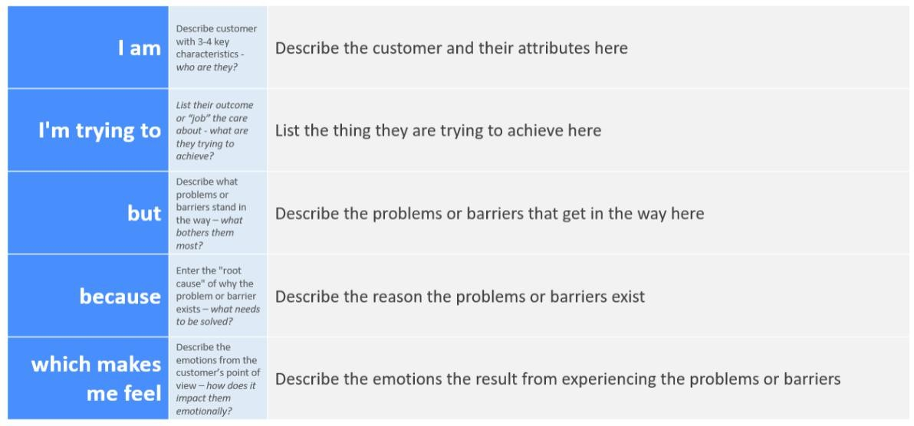
Reference: https://miro.com/templates/customer-problem-statement/
Example:
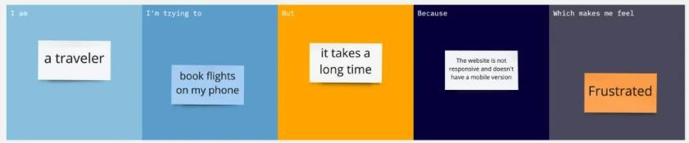

Problem Statement (PS) | I am (Customer) | I’m trying to | But | Because | Which makes me feel
PS-1 | A digital payment user who frequently uses UPI/credit/debit cards for online transactions | To complete secure and fast online payments | I am worried about fraud and unauthorized transactions | Fraudsters use advanced techniques and current systems may not detect fraud  instantly | Anxious, insecure, and stressed about losing money
PS-2 | A bank or financial service provider handling thousands of daily transactions | To prevent fraudulent transactions while ensuring smooth customer  experience | It is difficult to detect fraud in real- time without blocking legitimate users | Fraud patterns constantly evolve and datasets are highly imbalanced | Pressured, concerned about financial loss and customer trust

